华扬韩文网站购买流程—英文说明
HUA YANG 국제 공식 사이트 구매 절차 영문 가이드
Dear TVpad users,
Take the language habits of overseas korean into consideration, so we offer English commentary to help you learn the ordering process for your reference.

1. It will go to the page below when you click “Ahout Products” in the Homepage.
 제품 상세보기 About Products

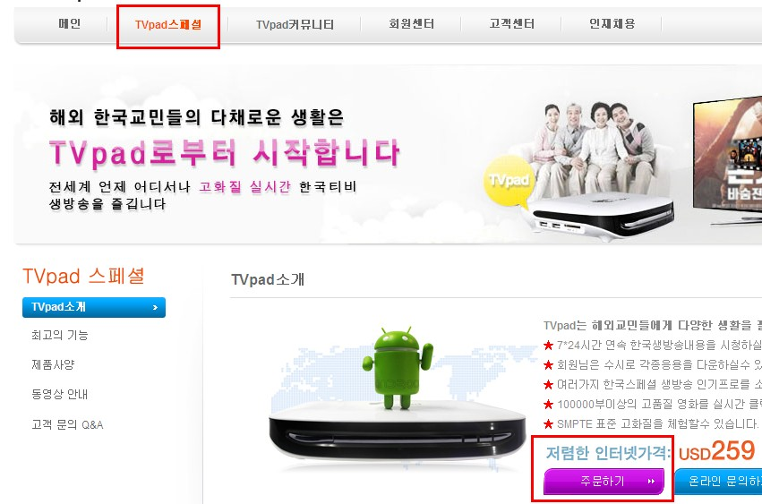

2. The page below will show when you click “Buy Now（주문하기）” in the TVpad page（TVpad스페셜 ）.

주문하기 Buy Now

3.
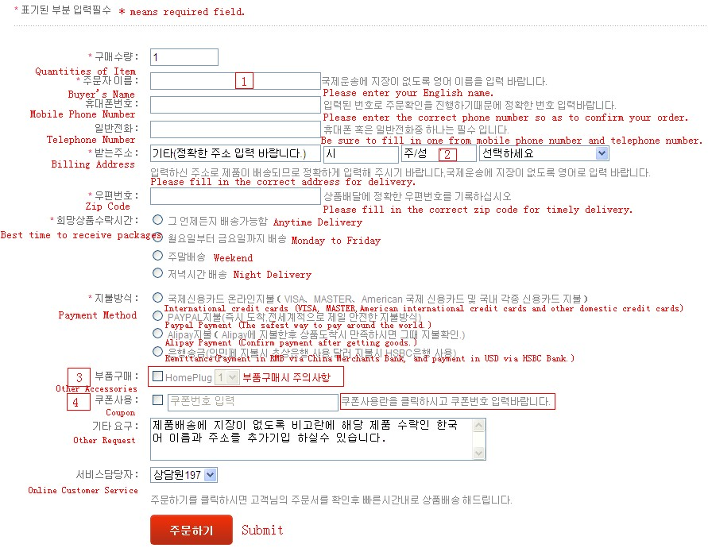

4. All the blank fields above are required, and pay attention to the following contents.

[Mark1] Due to delivery via international logistics companies, please fill out your name in English at “buyer’s name” field and your name in Korean or Chinese at “other request” field.
[Mark 2] Enter your billing address in English, if your address is no need to fill out state and province, please type in “N/A” in this blank field and enter your request in “other request” field.
[Mark 3]If you want to buy other accessories, please confirm name of items and select its quantities.
[Mark 4] If you use coupon code, please type in your coupon code, and then it will show coupon amount and date of expiry behind the input field for your confirmation.

Introduction of TVpad
TVpad, is a smart set top box which is designed for korean, can help Korean watch Solive and over 100,000 HD Korean shows on demand.
TVpad is a network set top box based on Android Operation System, and it is specialized in offering HD Korean TV videos service and own much video resources from internet including 10+ Korean Live Channels with high quality and over 100,000 Movies On Demand. Better still, the supplier will continuously update the latest videos and TV shows for you.

Important Feature of TVpad:
Price system of No monthly fee and No package
Watching any show based on network is not subject to regional influence
Easy and simple installation
Supports TF card and native play with high definition
Lifetime Software Support and 1 Year Warranty
Over 100,000 movies On Demand be updated everyday

Let’s watch Korean Live TV or Video On-Demand (VOD) with TVpad right now!
TVpad official website：http://www.tvpad.info

